STAR BIOGRAPHY

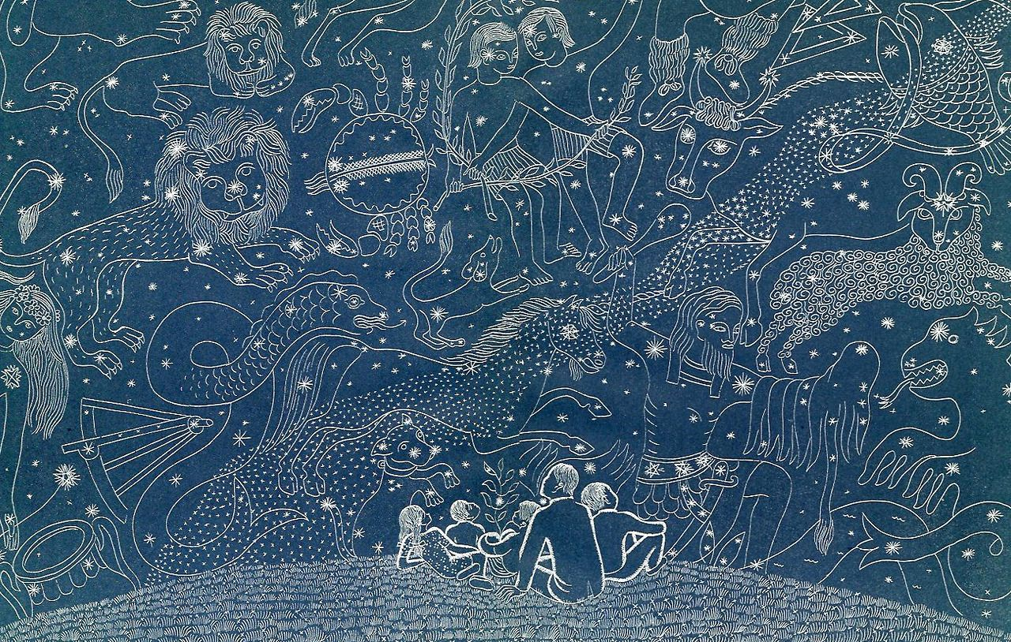

This project will allow you to research and gather information on a star that can be readily seen in the skies of Los Angeles. You will create a presentation (PowerPoint or Google Slides) to present your star biography. You are to gather the following information about your star (when available):

- Proper name (linked to the star's story – include as much of this story in your star introduction – the proper name is the name of the star you are assigned)
- Greek letter name (linked to a labeled photo of the star's constellation)
- Spectral class (CLASS); (Letter and Star-type, Luminosity and Temperature)
- Constellation (list the constellation this star is part of and the constellation myth- or the story/meaning of the myth)
- Distance (DIST) in light years
- Three (3) events that were taking place on Earth when the light we see from your star today was being emitted (See explanation below) – Include pictures/images for each event.

You are to use the Distance in Light Years (ly) to create a series of information slides about what was happening here on Earth when the light we are seeing left your star. For example, Polaris is 432 ly away from Earth. It being 2021, the light from Polaris that we see today originally left that star in the year 1589. (2021 – 432 = 1589)
*You would then research to find three major events that occurred on Earth in the year 1589 to include in your presentation.

Due Date: Friday 28MAY, 2021

Name _____________________________

Star (Proper Name) ____________________________

